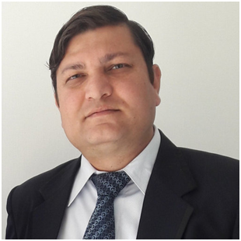

**DR. RAJ KUMAR SINGH**

**DEGREE OBTAINED:** M.Sc. (Organic Chemistry; 2005)

**CURRENT POSITION:** Principal Scientist

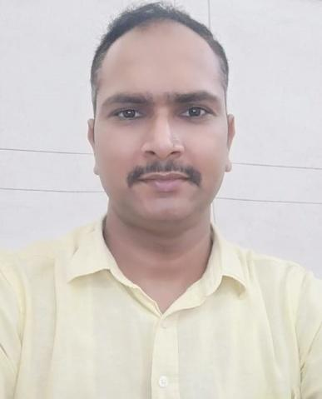

**DR. KULDEEP MISHRA**

**DEGREE OBTAINED:** M.Sc., PhD (2013)

**CURRENT POSITION:** Assistant Professor (HOD Dept. of Physics)

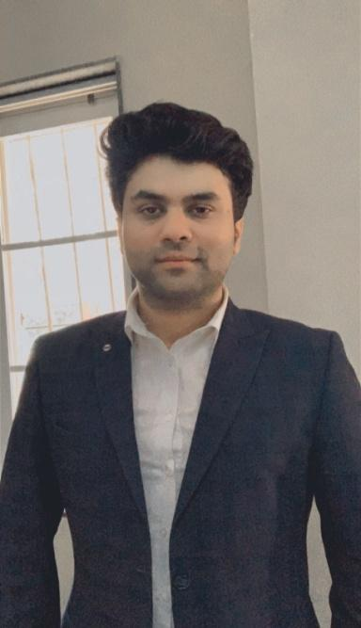

**DR.PANKAJ DIXIT**

**DEGREE OBTAINED:** [M.Com](http://m.com).

**CURRENT POSITION:** Assistant Professor

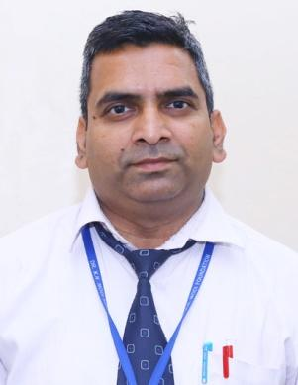

**PRAMOD KR. GARG**

**DEGREE OBTAINED:**  M.Com.,

**CURRENT POSITION:**  Professor

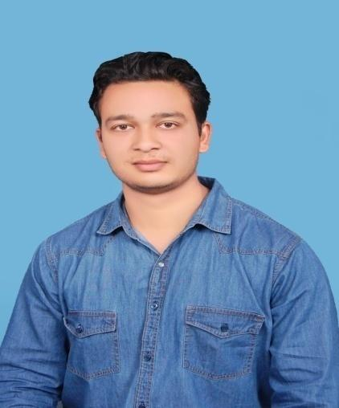

**Yogesh Tiwari**

**DEGREE OBTAINED:**  M.Com.

**CURRENT POSITION:** Territory Sales Manager

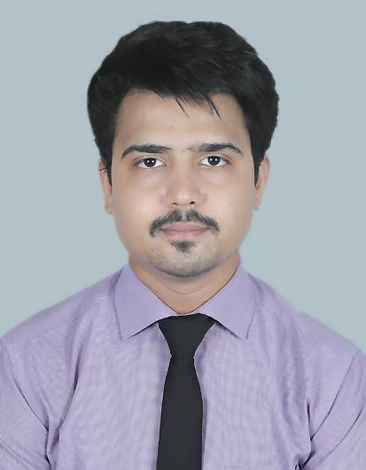

**Anuj Sharma**

**DEGREE OBTAINED:** M.Sc. Biotechnology

**CURRENT POSITION:** Scientific Business Officer

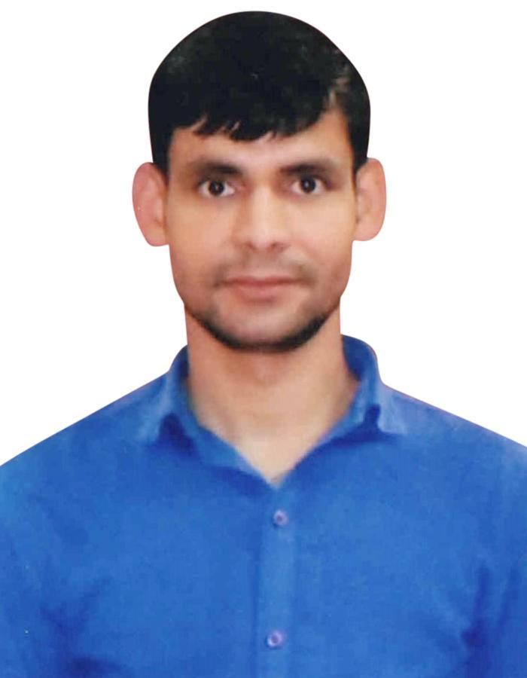

**ARVIND KUMAR**

**DEGREE OBTAINED:** M.Sc.

**CURRENT POSITION:** PhD (Pursuing)

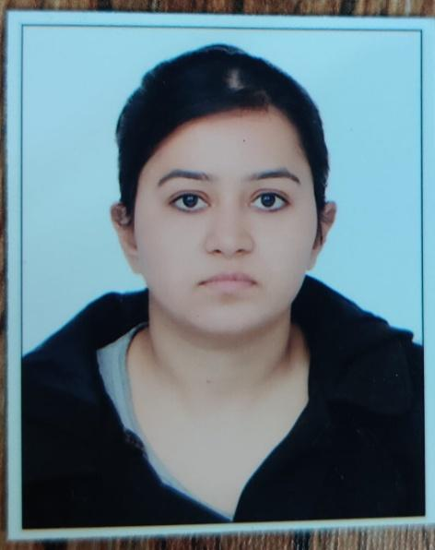

**Dr. Jyati Dixit**

**DEGREE OBTAINED:** Ph.D. (English)

**CURRENT POSITION:** Assistant Professor

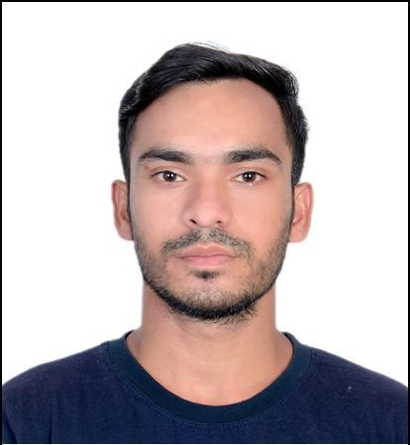

**Anit kumar**

**DEGREE OBTAINED:** B.Sc., M.Sc. (Botany)

**CURRENT POSITION:** Teaching,

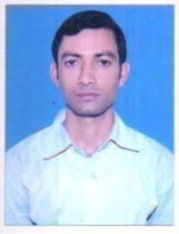

**Dr. Deepak kumar**

**DEGREE OBTAINED:** PhD, History

**CURRENT POSITION:** Assistant Professor,

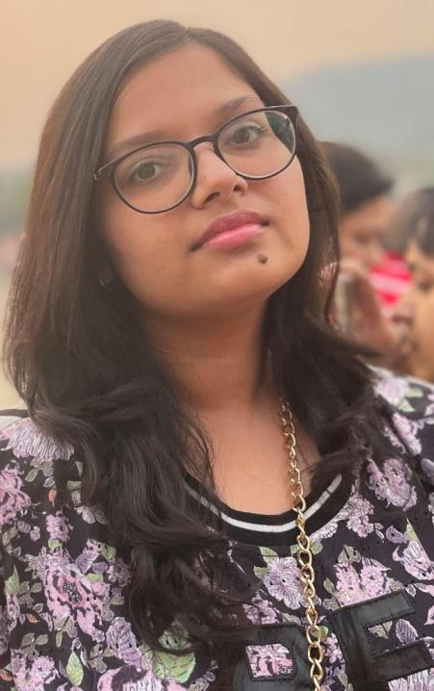

**Divya Kaushik**

**DEGREE OBTAINED:** M.Sc. Biotechnology

**CURRENT POSITION:** Project Assistant

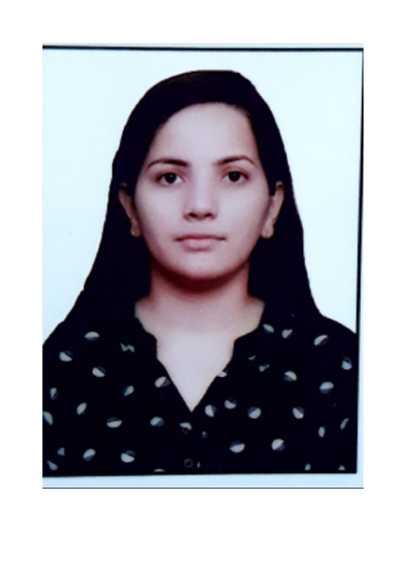

**RITIKA CHAUDHARY**

**DEGREE OBTAINED:** M.Sc. Biotechnology

**CURRENT POSITION:** Junior Research Fellow

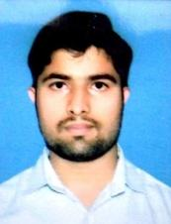

**Vishal**

**DEGREE OBTAINED:** B.A., (2019), M.A. (History)

**CURRENT POSITION:** Ph.D.(Pursuing),



**Durga Bajaj**

**DEGREE OBTAINED:**  [B.Com](http://b.com)

**CURRENT POSITION:** Scout Guide Training Counselor,

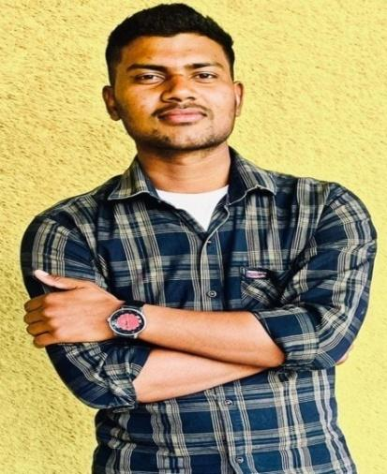

**SACHIN KUMAR**

**DEGREE OBTAINED:** MA (History)

**CURRENT POSITION:**  U.P. Police

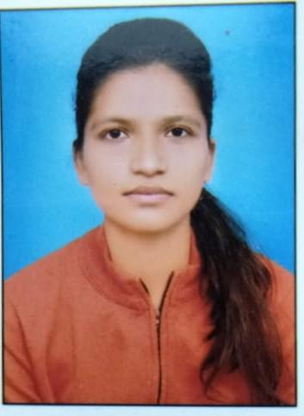

**Anchal**

**DEGREE OBTAINED:** M.A. (History), Ph.D. (Pursuing)

**CURRENT POSITION:** Assistant Professor

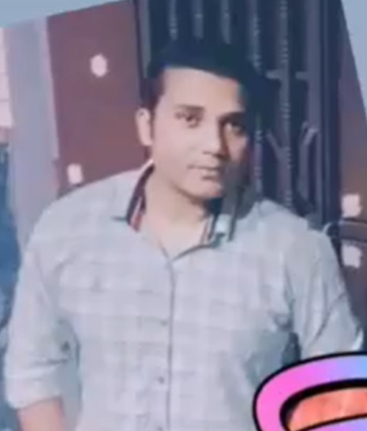

**Shivang Pal**

**DEGREE OBTAINED:** B. Sc. (PCM)

**CURRENT POSITION:** UP police

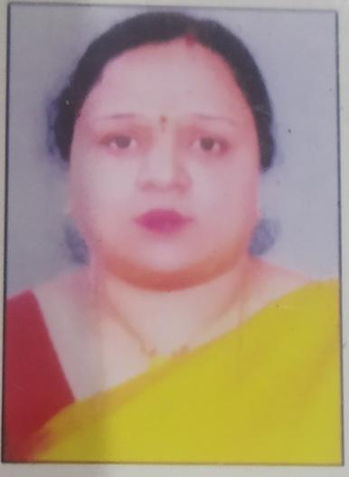

**Ekta Gupta**

**DEGREE OBTAINED:** B.Sc., M.Sc, PhD

**CURRENT POSITION:** Professor

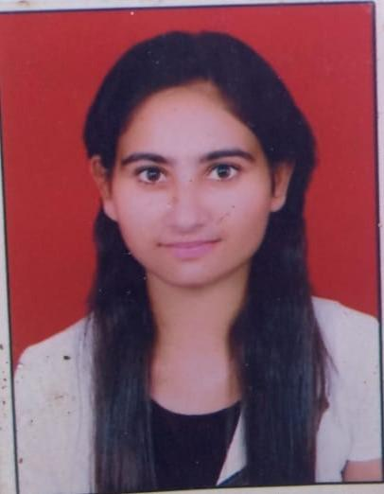

**Shivangi tyagi**

**DEGREE OBTAINED:**

**CURRENT POSITION:** Executive Customer Relationship

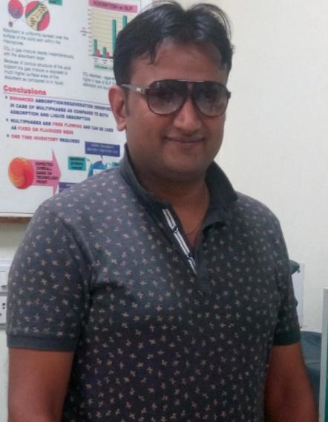

**Dr Pradeep Kumar Tyagi**

**DEGREE OBTAINED:** B.Sc, M.Sc. Chemistry

**CURRENT POSITION:** Senior Technical Officer

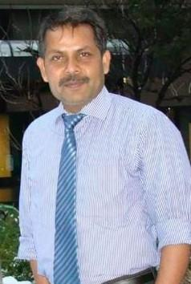

**Dr Anand Pal Singh**

**DEGREE OBTAINED:** B.Sc., Ph.D.

**CURRENT POSITION:** Assistant Controller of Patents

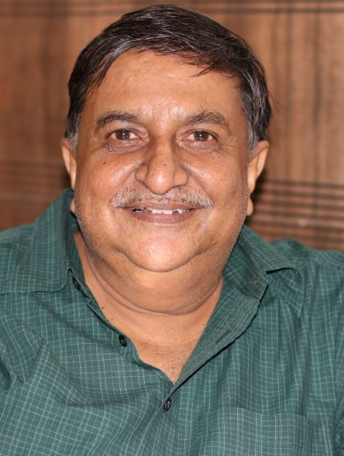

**SANJAY KR. MASKARE**

**DEGREE OBTAINED:** B.Com, (1984)

**CURRENT POSITION:** Assistant Accountant

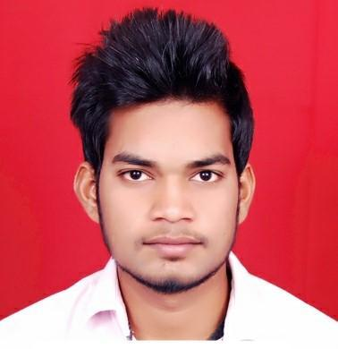

**Manish Kumar**

**DEGREE OBTAINED:** M.Sc. Biotechnology

**CURRENT POSITION:** Microbiologist

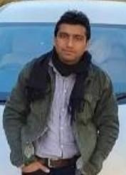

**Money Tyagi**

**DEGREE OBTAINED:** BCA

**CURRENT POSITION:** Software Engineer

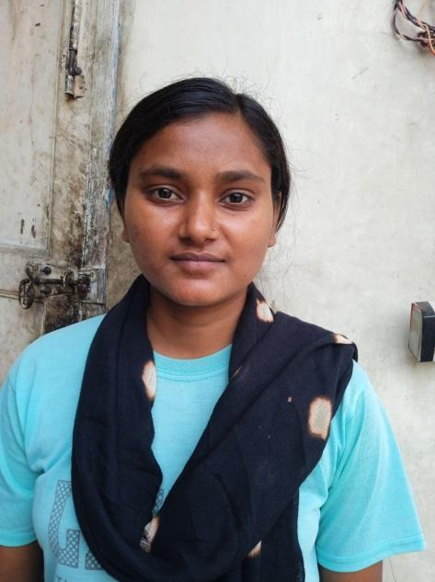

**SUSHMA**

**DEGREE OBTAINED:** M.A. Hindi

**CURRENT POSITION:** Teacher

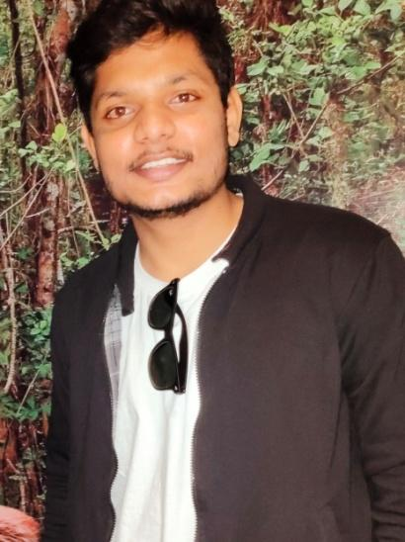

**Akash Kumar Prajapati**

**DEGREE OBTAINED:** [B.Sc](http://b.sc).

**CURRENT POSITION:** Working with SNCF Nirankari

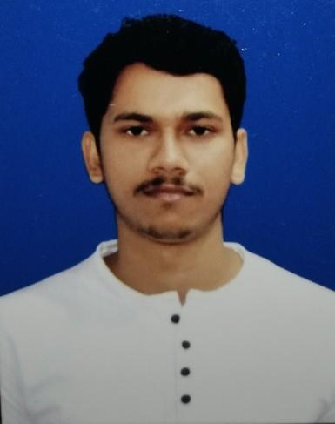

**Sachin kumar**

**DEGREE OBTAINED:** MA

**CURRENT POSITION:** UP Police

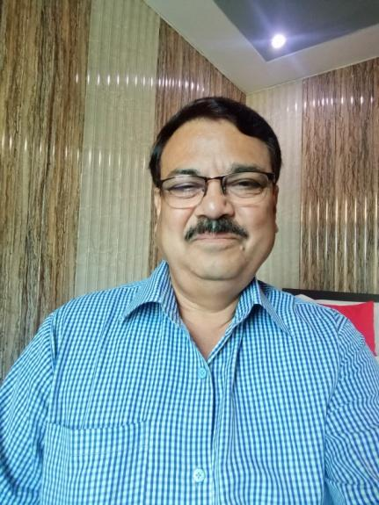

**Liaquat Ali**

**DEGREE OBTAINED:** B.Sc. (CBZ)

**CURRENT POSITION:** Former Station Superintendent,

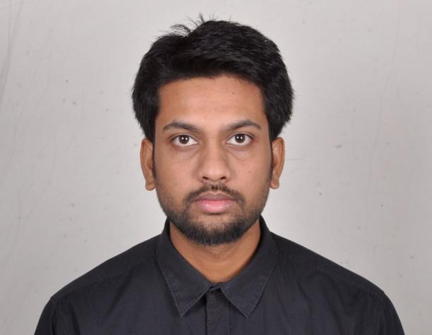

**Abhay Kant Srivastava**

**DEGREE OBTAINED:** M.Sc. (Physics)

**CURRENT POSITION:** Doctoral Researcher

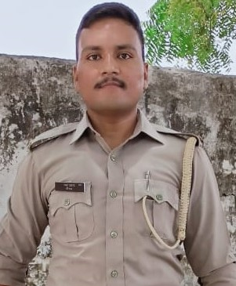

**NEERAJ**

**DEGREE OBTAINED:** B.Sc.,

**CURRENT POSITION:** UP POLICE PAC

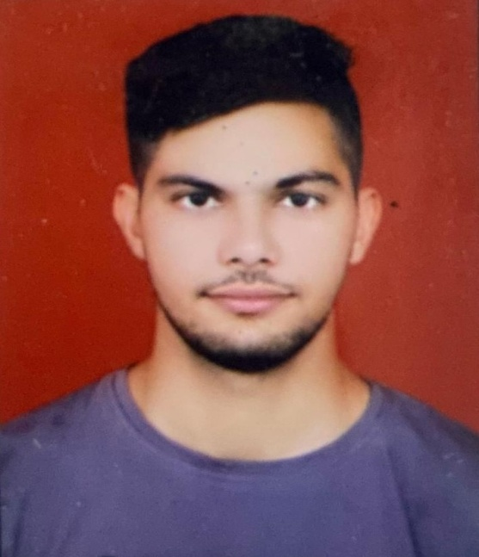

**RAMAN CHAUDHARY**

**DEGREE OBTAINED:**  B.Sc.,

**CURRENT POSITION:** UP POLICE PAC

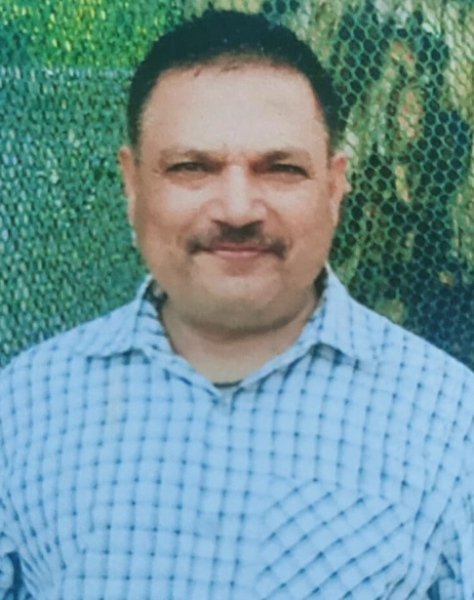

**SATYA PAL SINGH**

**DEGREE OBTAINED:** M.Com.,

**CURRENT POSITION:** Service, U.P.

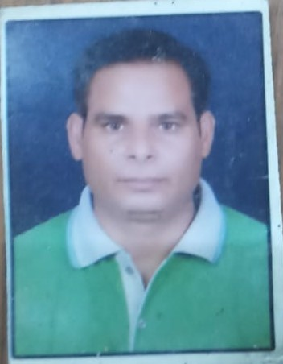

**DR.DEEPAK SHARMA**

**DEGREE OBTAINED:** B.Sc.; M.A.,

**CURRENT POSITION:** Assistant Professor

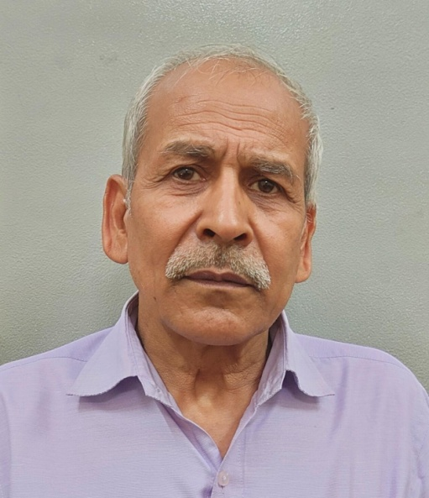

**RAJENDER KUMAR**

**DEGREE OBTAINED:** M.Com.,

**CURRENT POSITION:** Service, U.P.

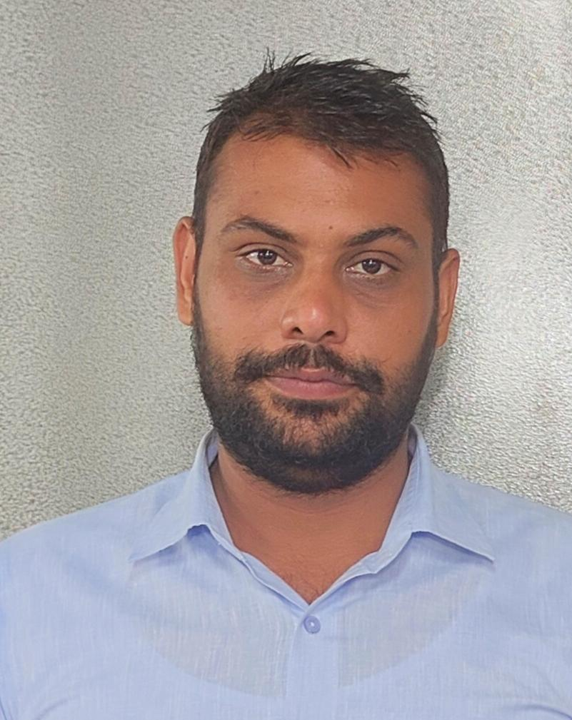

**SAURABH**

**DEGREE OBTAINED:** B.A,

**CURRENT POSITION: Service, U.P.**